Native American art work , in the newark museum. (From the state)
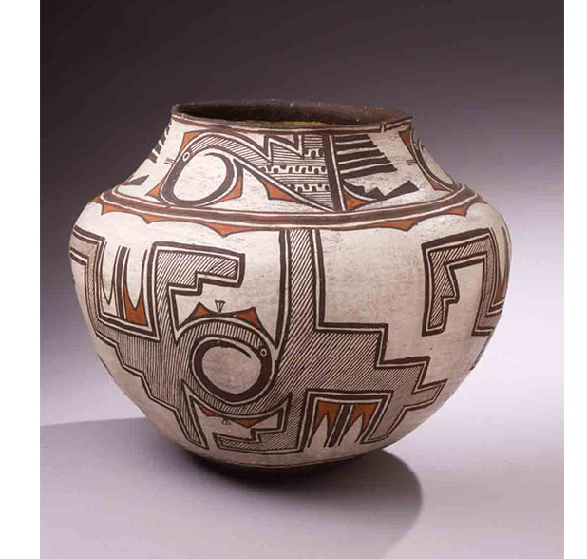
http://www.newarkmuseum.org/native-artists

https://www.montclairartmuseum.org/exhibition/native-american-art-collection-installation-pueblo-indian-pottery .
Native American art work , in the MAM (monticair museum)
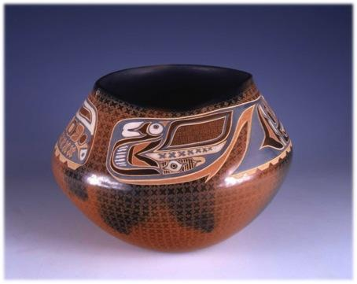
From the state , the newark museum.
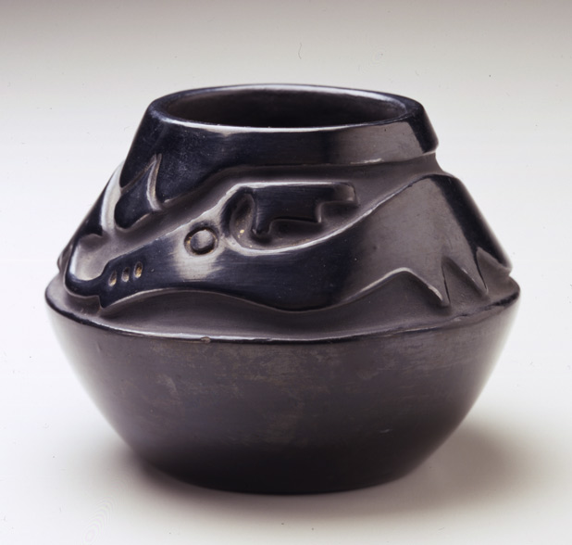
http://www.newarkmuseum.org/arts-americas
Rose Gonzales, Bowl, ca. 19401234 SHARE EXHIBITION
Native American art work , from the national museum of the american indian. (from out of the state)
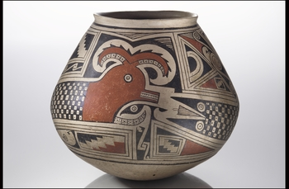
http://nmai.si.edu/searchcollections/item.aspx?irn=128617&catids=0&catnum=119739&src=1-5

